Course Specialist Year 12 Test Four 2022

Student name: ________________ Teacher name: ________________

Task type: Response

Time allowed for this task: _____40______ mins

Number of questions: _____6______

Materials required: Upto 3 Calculators with CAS capability (to be provided by the student)

Standard items: Pens (blue/black preferred), pencils (including coloured), sharpener, correction fluid/tape, eraser, ruler, highlighters

Special items: Drawing instruments, templates, notes on one unfolded sheet of
A4 paper, and up to three calculators approved for use in the WACE examinations

Marks available: __40____ marks

Task weighting: _10___%

Formula sheet provided: Yes

Note: All part questions worth more than 2 marks require working to obtain full marks.

Q1 (5 marks)

Determine the volume of the solid formed by rotating the area enclosed between about the y axis, as shown below.
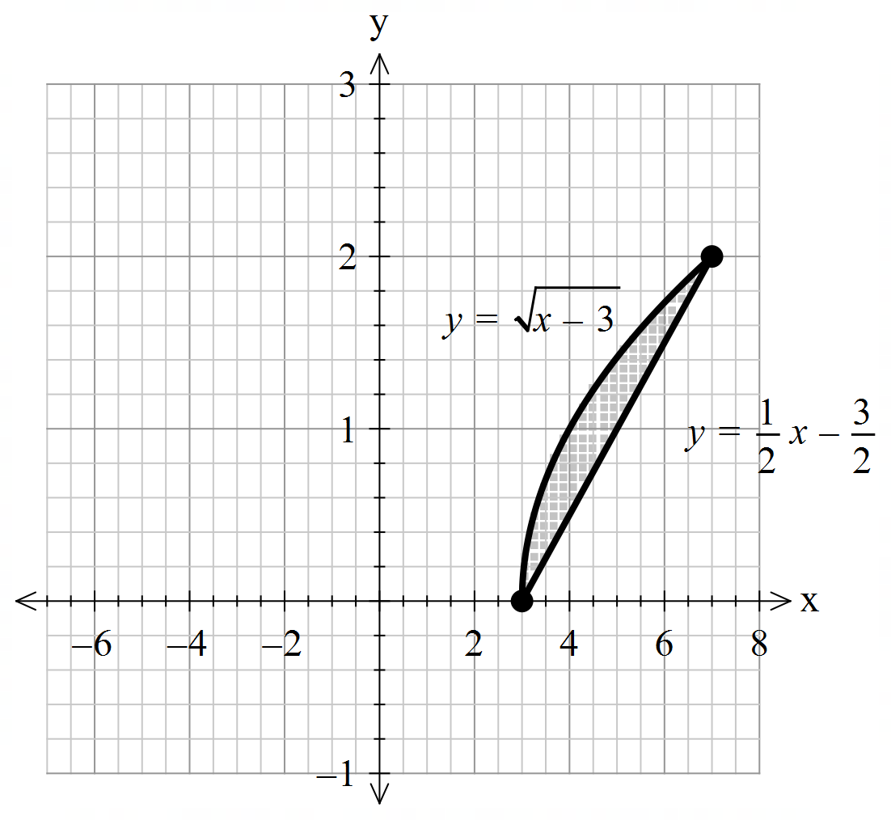

Solution

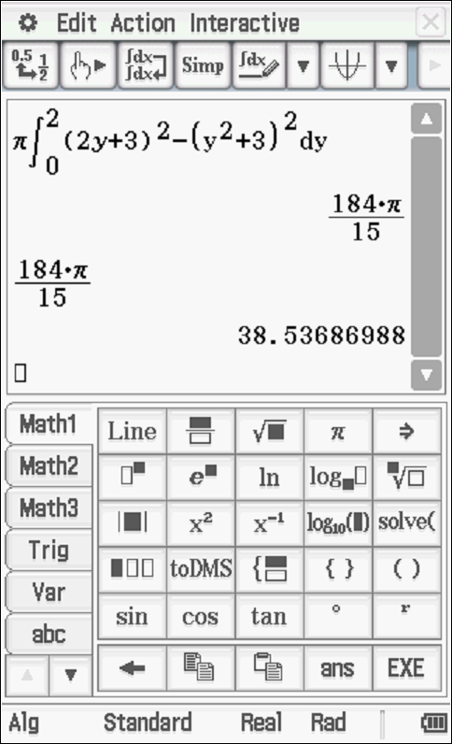
Specific behaviours
uses correct integral type
determines x as the subject for each graph
sets up integrals for both functions with limits
uses subtraction after squaring
states approx. volume of solid

Q2 (5, 3 & 2= 10 marks)
- By using integration and partial fractions, show how to derive from the differential equation () and is a constant

Solution
Specific behaviours
explains limit of N and sign of a-bN
separates dN & dt and integrates
uses partial fractions
uses logs and obtains expression of N in terms of t
shows derivation of final rule

Q2 continued
- Let equal the number of kangaroos living in a habitat after years and .If initially there are kangaroos, determine the number in 10 years time.

Solution

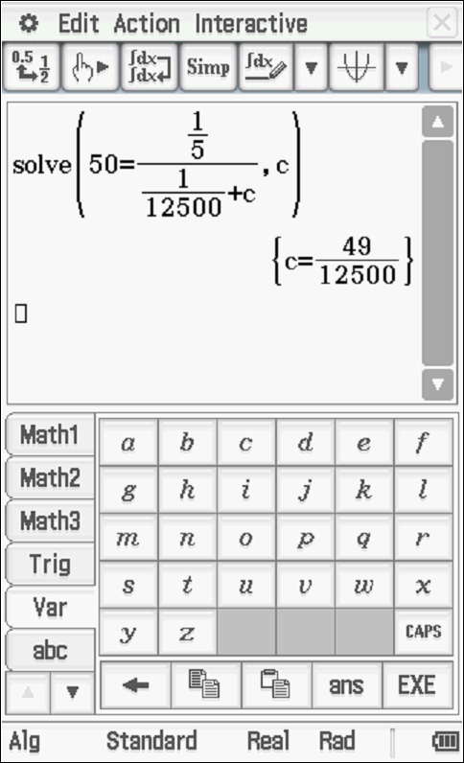
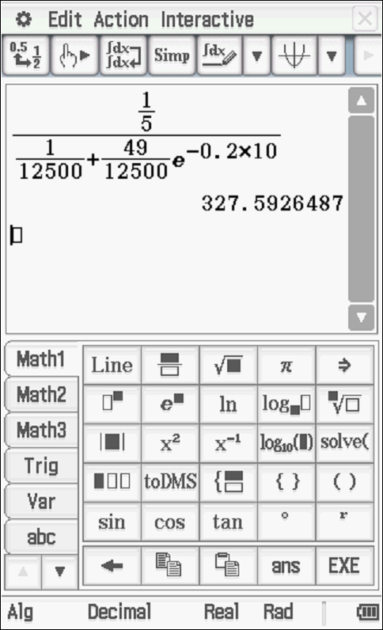

Specific behaviours
solves for constant
subs t=10 into correct expression
states population (accept decimal)

- Determine the size of the population at the maximum growth rate.

Solution
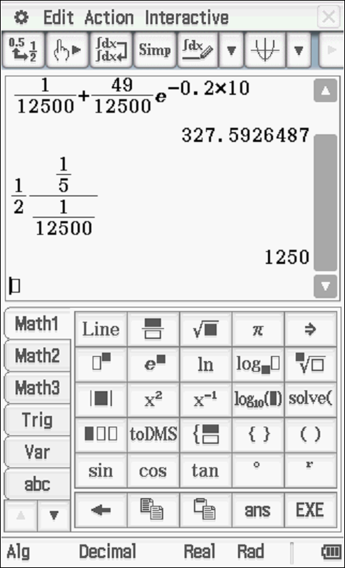

Specific behaviours
uses half of maximum
States population

Q3 (3, 2 & 3 = 8 marks)
- Sketch the slope field on the axes below for

Solution
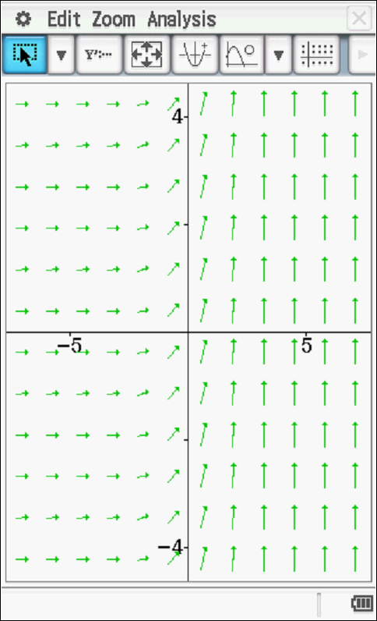

Specific behaviours
left side near zero gradients
45 degrees on y axis i.e 1
right side approaches vertical lines, i.e infinite

- Show the solution curve on the axes above that passes through point (2,2).

Solution
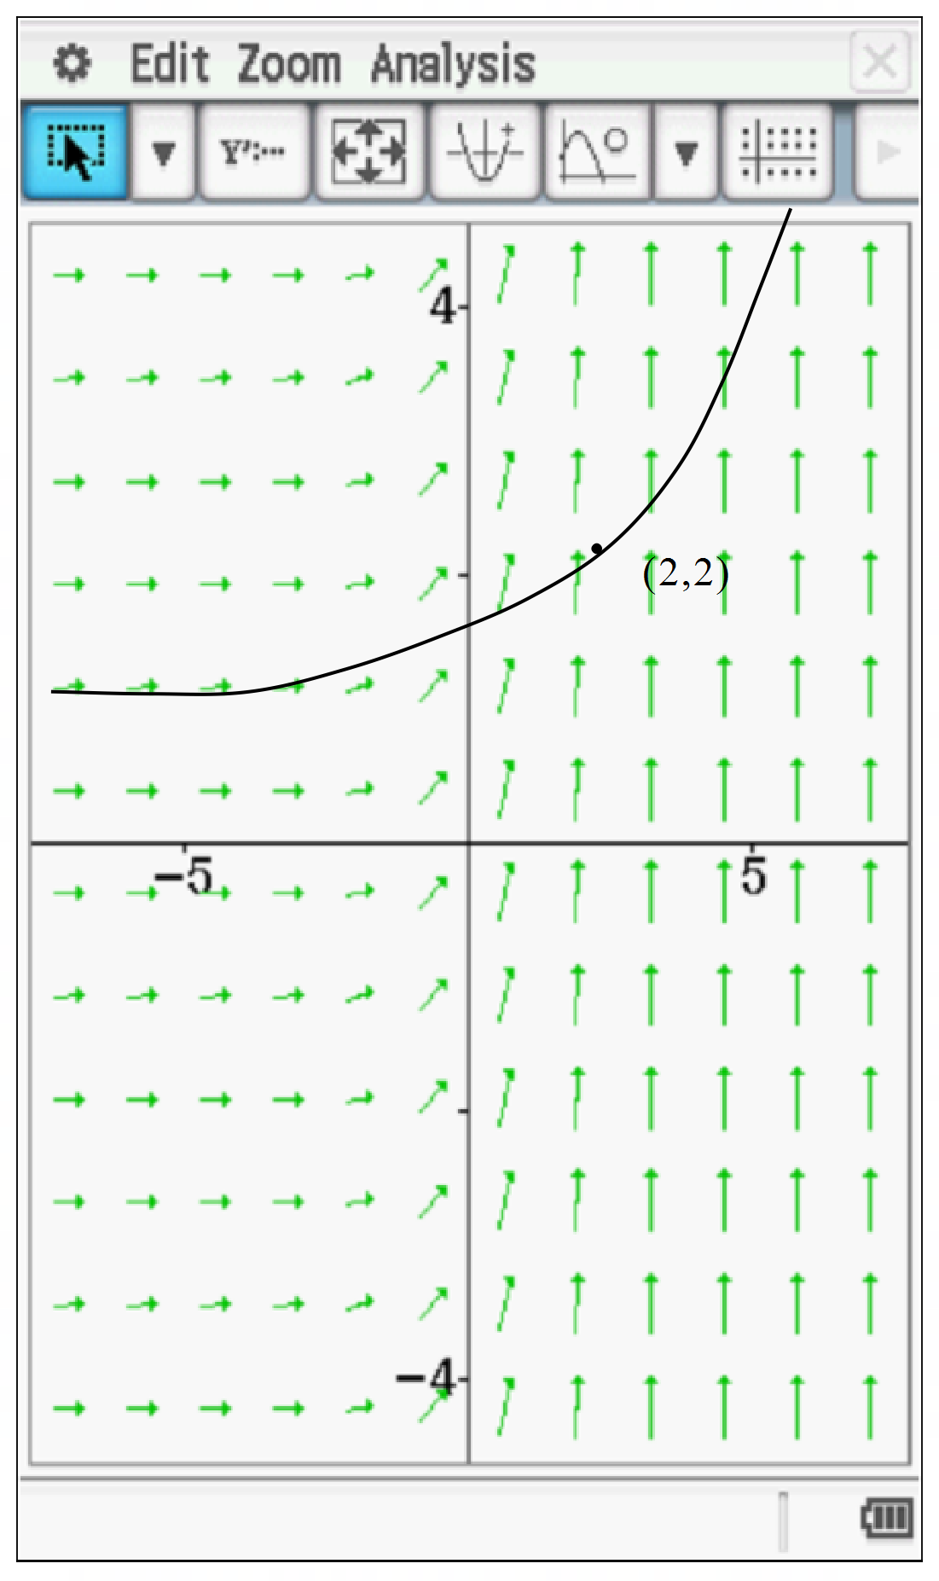

Specific behaviours
follows contours
passes through (2,2)

- Determine in cartesian form the solution curve for b above without using a classpad.
Hint – use logarithmic differentiation. Show all working.
Solution
Specific behaviours
uses log diff to diff exponential
uses integration
solves for exact constant
Note max 1 out of 3 if log diff not shown

Q4 (5 marks)
Determine expressions in terms of only for in terms of using the following equation

Solution
Specific behaviours
uses product rule on both sides for first derivative
uses implicit diff in terms of x
uses product/quotient rule for second drivative
obtains an expression with second derivative
makes second derivative subject in terms of x,y and first derivative

Q5 (3 & 3 = 6 marks)

Consider a particle that is moving with SHM such that with a maximum speed of 12 m/s.
- Determine the exact speed when the particle is half of an amplitude from the origin.

Solution
Specific behaviours
determines n & A
uses correct formula
states exact speed

- Determine the percentage of the time that the particle is more than half an amplitude from the centre.

Solution
Let

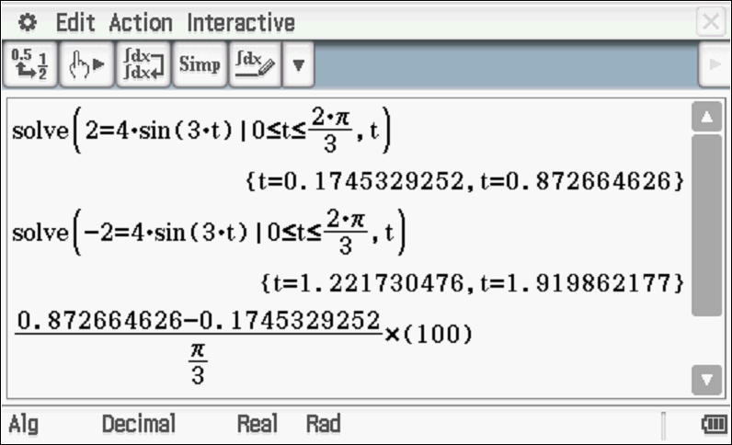
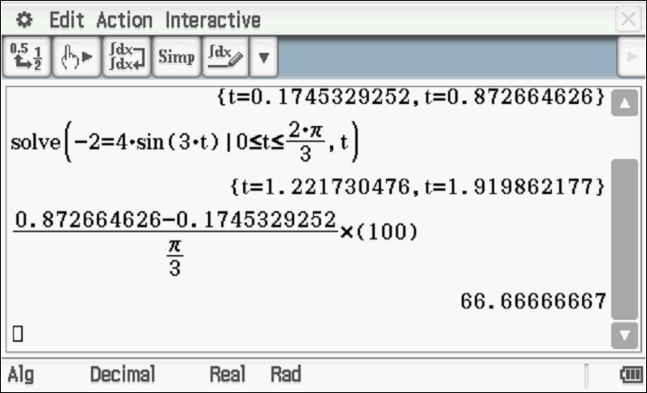
Specific behaviours
determines a model for displacement and period
solves for times at half an amplitude in one cycle/(half cycle)
determines percentage of time

Q6 (4 & 2 = 6 marks)
The motion of a bullet through a wall is modelled by the equation where is its acceleration and its velocity seconds after impact. Initially the speed is 300 and is at the origin (metres)

- Determine in terms of .

Solution
Specific behaviours
uses dv & dx and separates variables v & x
Integrates both sides
changes variable to integrate dv
solves for exact constant

Q6 continued-
- Determine how far the bullet penetrates the wall before coming to rest to the nearest mm.
Solution
Specific behaviours
subs v=0
rounds to nearest mm

